The Use of Supercritical CO₂ in the Electroplating of Metallic Coatings for their Performance Improvement

Chun-Ying Lee^{1*}, Van-Cuong Nguyen², and Kun-Jeng Peng³

¹Institute of Manufacturing Technology, National Taipei University of Technology, Taipei City, 10608, Taiwan
²Directorate of Vocational Education and Training, Ministry of Labour, Invalids and Social Affairs, Hanoi, Vietnam
³Department of Materials Science and Engineering, Ming Chi University of Technology, New Taipei City 24301, Taiwan
*Corresponding author: +886-2-87731614,  +886-2-27317191and leech@ntut.edu.tw

Abstract
The electrodeposition process has been intensively used in both surface modification of various industrial components and electroforming of micro-electro-mechanical systems (MEMS). The use of supercritical CO₂ (Sc-CO₂) was an eco-friendly adaption in electrochemical process for improving the coating’s properties with less incorporation of some harmful reagents in the manufacturing. In this presentation, both the electroplating and electroless plating processes of metallic coatings such as nickel, copper and zinc films with the assistance of Sc-CO₂ were discussed. Fig. 1 presents that the Sc-CO₂ assisted electroplating processes were able to significantly increase the coating’s hardness from their conventional counterparts. The coatings with nano-sized grains also improved their corrosion resistance and surface finish. However, higher internal stress arose with this grain reduction and more crystalline defects were induced. On the other hand, the Sc-CO₂ assisted electroless nickel plating was shown to facilitate the nickel metallization in PCB’s vias without the resort to surfactants used in conventional plating, as presented in Fig. 2. The possible mechanism for the process improvement will be discussed. Furthermore, toward developing more eco-friendly electroplating system, the combination of Sc-CO₂ and deep-eutectic solvent (DES) for the plating of nickel was also proposed and some preliminary results were presented.

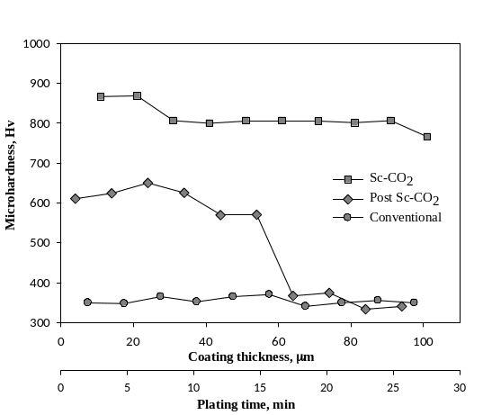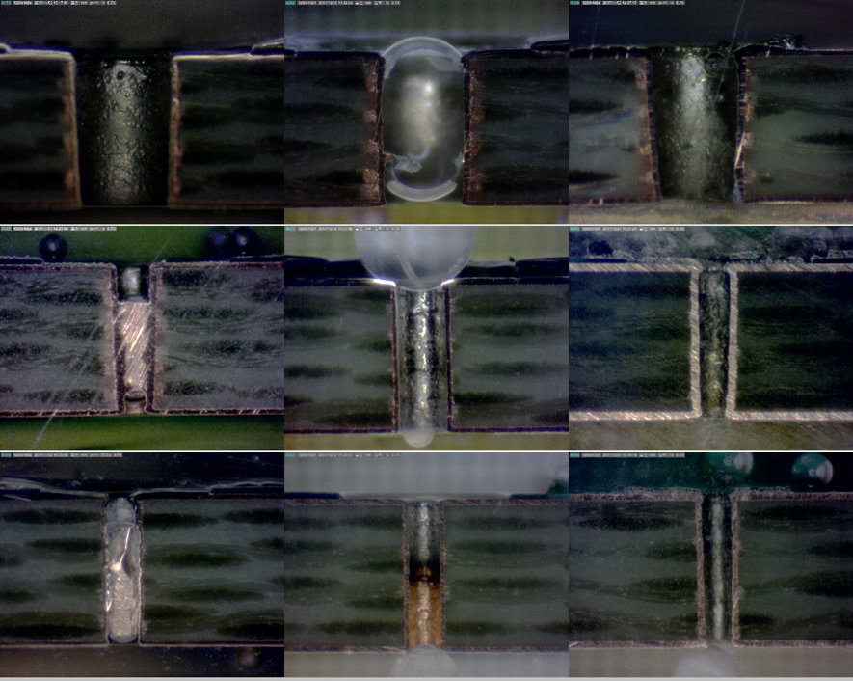
Fig. 1 Microhardness at cross section plane of nickel coatings electroplated from different processes.
Fig. 2 The Sc-CO₂ assisted electroless nickel plating in different sized vias of printed circuit board.

