Abstract Format for the ICPMMT 2018 Conference

First Author¹, Second Author², and Third Author^{3*}

¹Affiliation, Address, City, State Zip Code, Country
²Affiliation, Address, City, State Zip Code, Country
³Affiliation, Address, City, State Zip Code, Country
*Corresponding author: Phone, Fax and E-mail address.

Abstract

This example abstract provides instructions on the format to be used when submitting the abstract to ICPMMT 2018 Conference organizer. Length of this abstract is one page. Margins should be at least 1” on all sides (1” on all sides preferred). Type font should be Times Roman 14 point for title and 12 point for other parts. The title should appear at the top, centered, and in bold. Add a single space with 12 point below title. The authors’ names should appear below the title, centered. Each author’s name should appear as a first name, middle initial (if applicable), and last name. A superscript numeral should designate the author’s organization. Add a single space with 12 point below list of authors. For each separate organization, the superscript numeral should appear followed by the address. Add a single space with 12 point below affiliations. Next, contact information of corresponding author should be given for the author serving as primary contact. This information should include phone number, fax number, and e-mail address. The e-mail address should be double checked since it will be used as the primary means of contacting the authors. No page numbering needed. The author may provide two figures below the text. The conference organizers reserve the right to edit this abstract for grammar and format since it may be used in the final program.
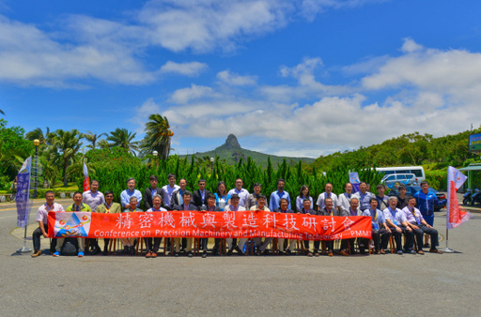
Fig. 1 The ICPMMT 2018 will be held in Auckland, New Zealand from February 4 to 8, 2018

Fig. 2 Photo of Auckland Hotel (just hotel sample,
it will be adjusted according to the real situation)

The template of abstract can be downloaded from http://www.icpmmt.org.
The abstract should be mailed to icpmmt@gmail.com.


